Understanding AngularJS $rootScope and $scope

## **$scope**

A $scope is a JavaScript object which is used for communication between controller and view. Basically, $scope binds a view (DOM element) to the viewmodel and functions defined in a controller.

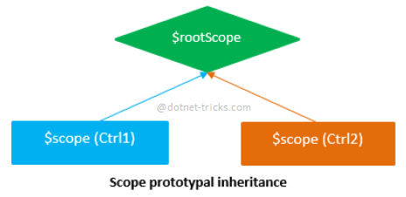

## **$rootScope**

The $rootScope is the top-most scope. An app can have only one $rootScope which will be shared among all the components of an app. Hence it acts like a global variable. All other $scopes are children of the $rootScope.

## **AngularJS : $rootScope and $scope with example**

1. **<!doctype html>**
2. **<html>**
3. **<body ng-app="myApp">**
4. **<div ng-controller="Ctrl1" style="border:2px solid blue; padding:5px">**
5. **Hello {{msg}}!**
6. **<br />**
7. **Hello {{name}}!**
8. **(rootScope)**
9. **</div>**
10. **<br />**
11. **<div ng-controller="Ctrl2" style="border:2px solid green; padding:5px">**
12. **Hello {{msg}}!**
13. **<br />**
14. **Hey {{myName}}!**
15. **<br />**
16. **Hi {{name}}! (rootScope)**
17. **</div>**
18. **<script src="lib/angular.js"></script>**
19. **<script>**
20. **var app = angular.module('myApp', []);**
22. **app.controller('Ctrl1', function ($scope, $rootScope) {**
23. **$scope.msg = 'World';**
24. **$rootScope.name = 'AngularJS';**
25. **});**
27. **app.controller('Ctrl2', function ($scope, $rootScope) {**
28. **$scope.msg = 'Seed Infotech';**
29. **$scope.myName = $rootScope.name;**
30. **});**
31. **</script>**
32. **</body>**
33. **</html>**

### **How it works...**

#### **Note**

1. When you use ng-model with $rootScope objects then AngularJS updates those objects under a specific $scope of a controller but not at global level $rootScope.
2. Create a private $scope for each controller to bind it to the view.